NEWS RELEASE
5 May 2020
Sure sees a 33% increase in home broadband usage since lockdown

Sure continues to play a critical role in providing connectivity for the community and has recorded a 33% increase in home broadband traffic since the Isle of Man Government announced the lockdown on 27 March.

With many island residents required to work or study from home and practice social distancing, Sure has reported a dramatic increase in home broadband traffic from an average usage of 73GB a week to 97GB a week per household. The community is also staying in touch over the phone regularly, with calls on mobile phones doubling during the lockdown period.

Despite a huge increase in demand and a dramatic change in home broadband consumption, Sure’s network has met the increased demand and continues to have spare capacity. Prior to the lockdown, peak hours for home broadband were between 5pm and 11pm as people returned from school and work and went online at home. Sure’s network usage data has revealed that the hours of high traffic volume have spread out across the day from 10am until 11pm.

According to the data, the demand for home broadband has also increased in the evening during lockdown as islanders stay in touch with their loved ones using the internet instead of face-to-face contact and watch popular TV streaming services.

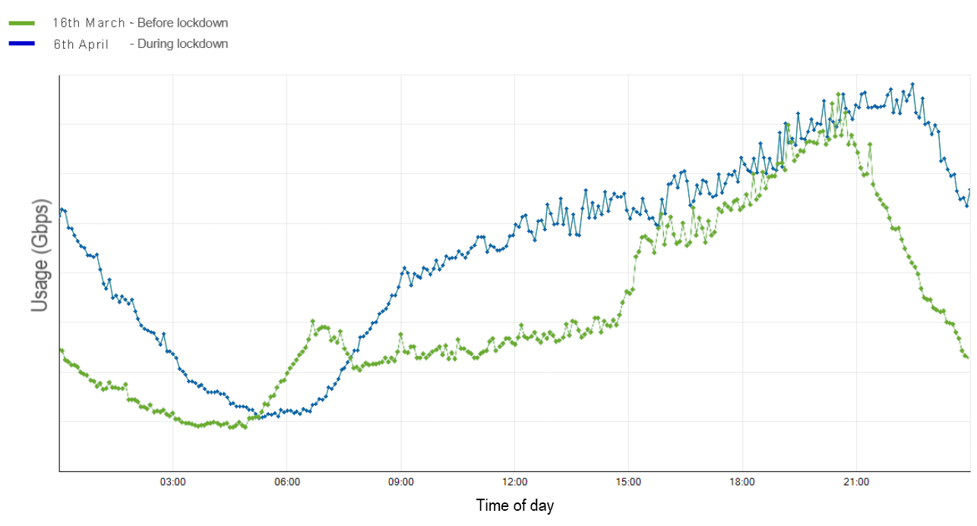

Mike Phillips, chief executive at Sure Isle of Man, said: “We're proud that Sure’s infrastructure has been able to easily absorb this increase in traffic and continues to help keep the community connected with the huge shift to working and studying from home.

“Everyone at Sure is working hard to ensure all customers can continue to access the national critical communication infrastructure that we provide across the Isle of Man. We have the procedures in place to maintain the resilience and capability of our networks and our operations.

“We have introduced a number of measures to ensure that we can help support the community and stay resilient such as launching a home delivery service and a range of home schooling packages, doubling the number of advisors on our webchat customer support and increasing the support for those directly and indirectly impacted by the coronavirus pandemic through the Sure Community Foundation.”

Cyrille Joffre, chief operating officer at Sure, added: “Working and schooling from home has resulted in a significant increase in network traffic as well as fixed line and mobile voice calls. Our long-term investment in our networks has allowed us to absorb the increase in demand and will continue to. This traffic is monitored 24/7 by our Service Operations Centre’s team members working from home.

“I feel proud to work with such great colleagues working tirelessly to maintain critical telecom infrastructure across the communities we serve.”

Details of the new connectivity measures can be found on the Sure website www.sure.com/coronavirus

#SupportingOurCommunity

ENDS
Issued by Emily Chapan, Orchard PR, 01481 251251, emilyc@orchardpr.com
Notes to editors:
About Sure

www.sure.com
Twitter: https://twitter.com/SureIOM
Facebook: https://www.facebook.com/SureIOM/
LinkedIn: https://www.linkedin.com/company/sure-international

Headquartered in Guernsey, Sure provides telecommunications and related services across the Channel Islands, the Isle of Man and in the British Overseas Territories of Ascension, Falklands, Saint Helena and Diego Garcia.

Sure provides fixed voice, mobile, broadband and Cloud services in the Channel Islands and Isle of Man. In the British Overseas Territories, Sure operates under exclusive licences with full-feature networks delivering voice, broadband data services and, in certain markets, TV. The corporate division of the business, Sure International, specialises in offshore connectivity, enabling those companies that operate in the islands to reliably and efficiently connect and transact with their global partners.

Sure’s approach to business is based on its values of simplicity, trust, one team and customer-driven. The last of these values has resulted in annual multi-million-pound investments to provide customers with the best and latest services to meet their needs.
Customer experience is at the heart of Sure’s approach and the company was found to have the most satisfied customers in the Channel Islands in a 2018 study carried out by the independent regulator in the islands. In the Isle of Man, Sure was rated the best overall network (Source: a Sure-commissioned independent study carried out by Systemics group, 2017).

Sure is a member of the Batelco Group, a leading telecommunications provider to 14 markets spanning the Middle East & Northern Africa, Europe and the South Atlantic and Indian Ocean.

